- Create numeric, character, and logical vectors and display type and content.
Aim:
To create numeric, character, and logical vectors and display type and content.
Procedure:
Step 1: Open RStudio or R console on your system.
Step 2: Create a numeric vector containing numerical values. Step 3: Display the contents of the numeric vector on the screen.
Step 4: Use the class function to check and print the data type of the numeric vector. Step 5: Create a character vector containing names or text values.
Step 6: Display the contents of the character vector.
Step 7: Use the class function to identify and print the data type of the character vector. Step 8: Create a logical vector containing TRUE and FALSE values.
Step 9: Display the logical vector on the screen.
Step 10: Use the class function to print the data type of the logical vector.
Step 11: Observe and note that numeric, character, and logical vectors each have distinct data types.
Program:
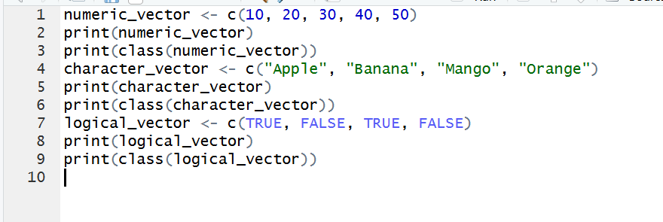
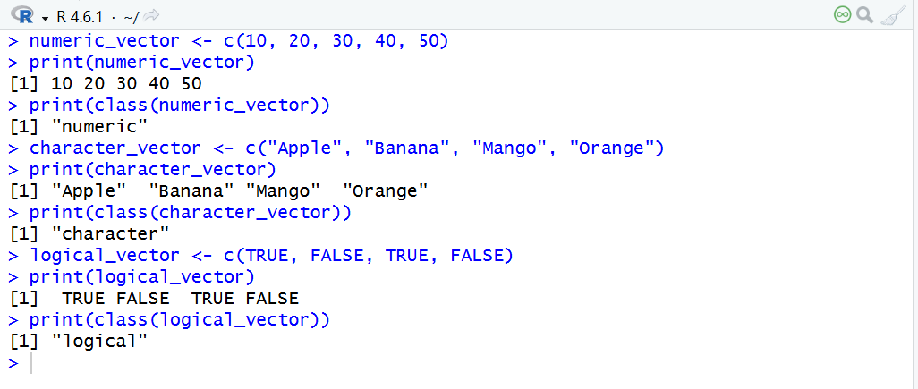
Result:
Hence the output is verified successfully.

